Epilepsy Management Pack

One of the aims of the Paediatric Epilepsy Network of NSW is to ensure that children and adolescents who are diagnosed with epilepsy receive the same high standard of care wherever they live in New South Wales.
The website (www.pennsw.org.au) ensures that standardised, high quality resources are readily available at the point of care to clinicians and families.

Checklist for newly diagnosed Epilepsy
Information for families
☐ General Safety
☐ First Aid Seizure Management Plan (day care/school/respite)
☐ Seizure First Aid
☐ Emergency Seizure Medication Order (if prescribed)
☐ Recommendation for CPR courses
☐ Seizure Diary
☐ PENNSW website

Medication
☐ Drug Treatment Plan
☐ Medication Information Handout

☐ Follow up appointment made with General Paediatrician

Safety

We all need to consider safety in our lives. In our day to day living, some activities we undertake are more risky than others. Children and adolescents with Epilepsy have potential other risks that must be considered. By being aware of these risks and minimising them, children with Epilepsy can live full and active lives. Your Doctor will be able to give you advice, but safety is a responsibility for all.

The risk of injury to a child or adolescent with Epilepsy depends upon several factors:
- Type of Seizures: there is increased risk if the seizures cause a loss of consciousness or occur without warning.
- Frequency of Seizures: there is increased risk if there are many seizures per day.
- Seizure Triggers: there are certain activities that can trigger a seizure, such as stress and tiredness.
- Age of child or adolescent.
- Type of Medications being used to control seizures: certain medications, especially at higher doses, can lead to certain side effects such as drowsiness and unsteadiness.
- Type of Activity: always consider the type of activity and the risk posed by having a seizure. Activities such as swimming, surfing, and bike riding are examples.
- Other neurological or health problems.

Safety precautions should be sensible and relevant to the individual child or adolescent.
There needs to be an appropriate balance between risk and restriction.

Children and adolescents with epilepsy need to especially consider the following activities:

- Swimming:
The pool, open-ocean, surfing and water skiing all pose potential risks to safety. Swimming in a pool with an adult watching closely is not too risky for most children. However, the adult must be prepared to watch the child at all times, be able to swim and assist in a rescue if needed. These precautions apply to school carnivals and swimming sessions, as well as family and teenage outings. Swimming in rivers/dams and surfing or swimming in the open ocean is far more dangerous than swimming in a pool. You always need to consider what you would do if the child were to have a seizure.

- Bathroom and toilets:
In general it is important that your child can not lock themselves into certain rooms in the house. This is so you can gain easy access if they were to have a seizure. Children and adolescents should have showers rather than baths. Your child is very vulnerable while bathing. Never leave your child unsupervised in the bath. The person supervising should be competent in giving first aid (generally an adult and not another sibling).

- Biking:
Wear a helmet when riding a bike. Ride on bike tracks and in parks and not on the road. Main roads, with high car activity, pose the greatest risk.

Safety continued…

  - Driving

If a young person who is already licensed to drive experiences a seizure, they must stop driving and seek medical advice. The AUSTROADS "Assessing Fitness to Drive" document details the legal requirements in relation to driving and seizure and can be accessed by visiting the website: https://austroads.com.au/drivers-and-vehicles/assessing-fitness-to-drive

  - Other

The following activities also carry extra risks for people who experience seizures and should be discussed with the treating doctor:

  - Use of heavy machinery and/or power tools
  - Activities at height (e.g. building jobs at height, outdoor rock climbing/abseiling)
  - Activities at pace (e.g. skiing, track racing)

Further information

Medic Alert Bracelets: Consider getting a medic alert bracelet for your child. This is a good way of first aid responders knowing quickly what your child's background history is (especially when you are not there).

Seizure Safety: Epilepsy Action has very good information on Safety. For further information please see:
- Epilepsy Action: Seizure Smart - Safety (a detailed information sheet on safety).
- Epilepsy Action: Seizure Smart - Safety Checklist (a thorough checklist which will help you tick off issues around safety once they have been addressed).

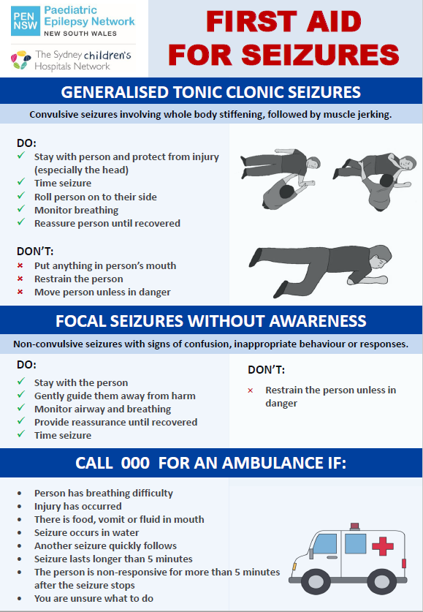

First Aid Seizure Management Plan
Child/Adolescent: |  |  |  |  |  | Date of Birth:
Parent/Guardian: |  |  |  |  |  | Contact Number(s):
Treating Clinician: |  |  |  |  |  | Contact Number(s):
Seizure Type 1
Seizure Type |  | Duration | Frequency |  | Description of the seizure – including triggers and warning signs
Specific First Aid Management:

Emergency medication order? |  |  |  | ☐ Yes (refer to attached administration sheet) |  |  |  |  |  | ☐ No
Seizure Type 2
Seizure Type |  | Duration | Frequency |  | Description of the seizure – including triggers and warning signs
Specific First Aid Management:

Emergency medication order? |  |  |  | ☐ Yes (refer to attached administration sheet) |  |  |  |  |  | ☐ No
General First Aid Principles
- Stay with the child and try to time the seizure
- Move hard objects away and protect head from injury
- Place on the side (recovery position) to keep airway clear
- Provide comfort and reassurance after the seizure and allow to rest and sleep
- If confused or unusual behavior, gently guide away from harm and ensure safety
- DO NOT place anything in the mouth
IF SEIZURE ACTIVITY CONTINUES OR THERE ARE MULTIPLE SHORT SEIZURES
FOR GREATER THAN 5 MINUTES, CALL FOR AN AMBULANCE – DIAL 000

Name of Prescribing  Doctor: |  |  |  |  | Signature: |  |  |  | Date:
Name of Parent: |  |  |  |  | Signature: |  |  |  | Date:

Emergency Seizure Medication Order
Child/Adolescent: |  |  |  |  |  |  |  |  |  |  |  |  |  |  |  | Date of Birth:
Parent/Guardian: |  |  |  |  |  |  |  |  |  |  |  |  |  |  |  | Contact Number(s):
Treating Clinician: |  |  |  |  |  |  |  |  |  |  |  |  |  |  |  | Contact Number(s):
Type of Seizure for which Medication has been prescribed
Seizure Type |  |  | Description of the seizure activity for which medication has been prescribed |  |  |  |  |  |  |  |  |  |  |  |  |  |  |  |  |  |  |  |  |  |  | Medication
1
2
Midazolam (5mg/1ml)
How is Midazolam to be given? |  |  |  |  |  |  |  |  |  | ☐ In nose (intranasal) |  |  |  |  |  |  |  |  |  | ☐ Inside cheek (buccal)
When is Midazolam to be given?
☐ As soon as the seizure starts
☐ If the seizure lasts longer than |  |  |  |  |  |  |  |  |  |  | minutes
☐ If |  |  |  |  |  | seizure as described above occur within |  |  |  |  |  |  |  |  |  |  |  |  |  |  | minutes/hours of each other
☐ If |  |  |  |  |  | seizure as described above occur within |  |  |  |  |  |  |  |  |  |  |  |  |  |  | minutes/hours of each other
☐ Special circumstances (please specify):
Patient Weight: |  |  |  |  |  |  |  |  |  |  |  | Patient Allergies:
Midazolam dose to be given: |  |  |  |  |  |  |  |  |  |  | mls, which is |  |  |  |  |  |  |  |  |  |  | mg
Other Emergency Seizure Medication
Other Medication name:
When is medication to be given?
☐ As soon as the seizure starts
☐ If the seizure lasts longer than |  |  |  |  |  |  |  |  |  |  | minutes
☐ If |  |  |  |  |  | seizure as described above occur within |  |  |  |  |  |  |  |  |  |  |  |  |  |  |  |  |  | minutes / hours of each other
☐ If |  |  |  |  |  | seizure as described above occur within |  |  |  |  |  |  |  |  |  |  |  |  |  |  |  |  |  | minutes / hours of each other
☐ Special circumstances (please specify):
Dose to be given: |  |  |  |  | Give
General First Aid Principles
Call for Ambulance on 000 if: Refer over page
Name of Prescribing Doctor: |  |  |  |  |  |  |  |  | Signature: |  |  |  |  |  |  |  |  |  |  |  |  |  | Date:
Name of Parent: |  |  |  |  |  |  |  |  | Signature: |  |  |  |  |  |  |  |  |  |  |  |  |  | Date:
Cardio Pulmonary Resuscitation

CPR COURSES IN NSW

St John NSW:
Caring for Kids
Phone number 1300 360 455
https://www.stjohnnsw.com.au/training/

Red Cross:
Provide CPR (4hours), Education and Care First Aid (8 hours)
Phone Number 1300 367 428 or 1800 733 276
https://www.redcross.org.au/get-involved/learn/first-aid

CPR KIDS:
First Aid for families in your own home (Sydney area)
Baby and Child specific first aid and CPR (3 hours 30 mins)
Phone number 1300 543 727
www.cprkids.com.au

Online CPR Training for Parents:
The Children's Hospital at Westmead has also developed a free online program
to teach the steps involved in CPR for a baby (aged less than 12 months)
or a child (aged over one year).
http://kidshealth.schn.health.nsw.gov.au/cpr

Event Diary
Child / Adolescent: |  |  |  |  | Date of Birth:
TIP: Capturing future events on video can be helpful for the treating Doctor. Video event IF child is safe.
Date | Month 1 | Month 2 | Month 3 | Other Information
1
2
3
4
5
6
7
8
9
10
11
12
13
14
15
16
17
18
19
20
21
22
23
24
25
26
27
28
29
30
Event Type |  | Description
A
B

Paediatric Epilepsy Network NSW

The PENNSW website (www.pennsw.org.au) provides information for children and adolescents living with epilepsy and their families, as well as clinicians involved in patient care. It includes educational resources on the following:
- Seizures explained
- Medicines
- Safety
- Coping with Epilepsy
- Diagnosis
- Emergency Management
- Seizure Plans
- Adolescent resources
- Transition information

